Composite Solids with Flat and Curved Surfaces

Definition
# Source: AI Source: Provided by: [Data Path: Persons Table -> ID Column: 1, Name_En Column: Motasem Essam] -> From: [ChatGPT] on [7/25/2026]
Composite solids with flat and curved surfaces are three-dimensional geometric objects that combine two or more geometric components, where the resulting solid has both planar (flat) surfaces and curved surfaces.
These solids may be formed by joining different geometric solids, such as prisms, pyramids, cylinders, cones, spheres, and hemispheres.
The combination of these components produces objects with a mixture of flat faces, curved surfaces, circular boundaries, and other geometric features.
Examples include:
- A cylinder with a hemisphere attached to one end.
- A rectangular prism with a semicylindrical top.
- A cone attached to a cylindrical base.
- A cube with a hemispherical dome.
- A cylinder with a conical top.
- A rectangular block with a cylindrical extension.

Simple Definition
# Source: AI Source: Provided by: [Data Path: Persons Table -> ID Column: 1, Name_En Column: Motasem Essam] -> From: [ChatGPT] on [7/25/2026]
A composite solid with flat and curved surfaces is a 3D shape made by combining geometric solids that have both flat faces and curved surfaces.
It contains planar surfaces, curved surfaces, or both, depending on the shapes used to construct it.

Geometric Representation
# Source: AI Source: Provided by: [Data Path: Persons Table -> ID Column: 1, Name_En Column: Motasem Essam] -> From: [ChatGPT] on [7/25/2026]
A composite solid with flat and curved surfaces may consist of several geometric elements:
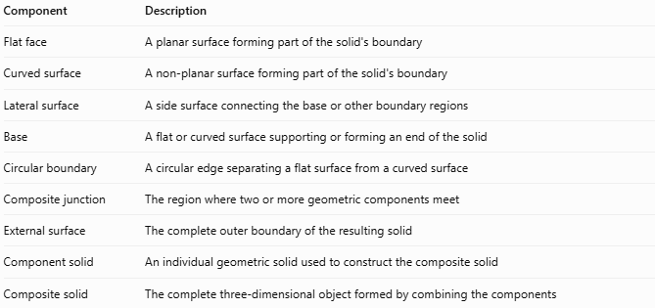
Component | Description
Flat face | A planar surface forming part of the solid's boundary
Curved surface | A non-planar surface forming part of the solid's boundary
Lateral surface | A side surface connecting the base or other boundary regions
Base | A flat or curved surface supporting or forming an end of the solid
Circular boundary | A circular edge separating a flat surface from a curved surface
Composite junction | The region where two or more geometric components meet
External surface | The complete outer boundary of the resulting solid
Component solid | An individual geometric solid used to construct the composite solid
Composite solid | The complete three-dimensional object formed by combining the components

Types of Composite Solids with Flat and Curved Surfaces
# Source: AI Source: Provided by: [Data Path: Persons Table -> ID Column: 1, Name_En Column: Motasem Essam] -> From: [ChatGPT] on [7/25/2026]
These solids can be classified according to the geometric components used in their construction.

Prism-Based Composite Solids
# Source: AI Source: Provided by: [Data Path: Persons Table -> ID Column: 1, Name_En Column: Motasem Essam] -> From: [ChatGPT] on [7/25/2026]
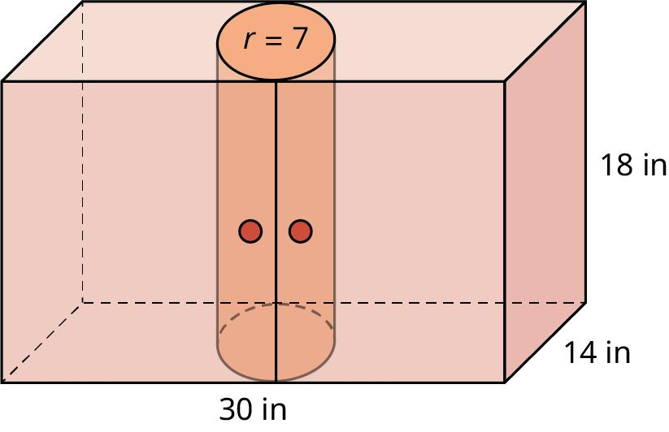
Created by combining a prism with one or more solids that have curved surfaces.
Examples:
- Rectangular prism with a semicylindrical top.
- Rectangular prism with a cylindrical extension.
- Cube with a hemispherical dome.
- Triangular prism with a semicylindrical section.
- Rectangular prism with a conical projection.

Cylinder-Based Composite Solids
# Source: AI Source: Provided by: [Data Path: Persons Table -> ID Column: 1, Name_En Column: Motasem Essam] -> From: [ChatGPT] on [7/25/2026]
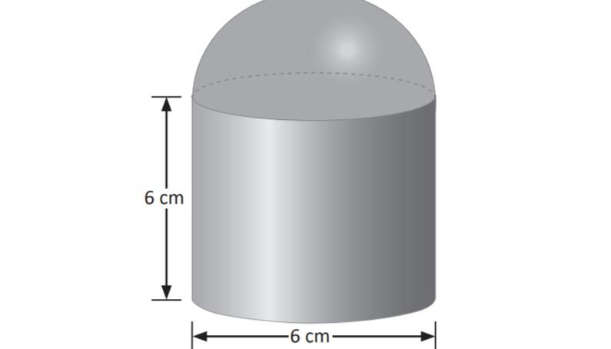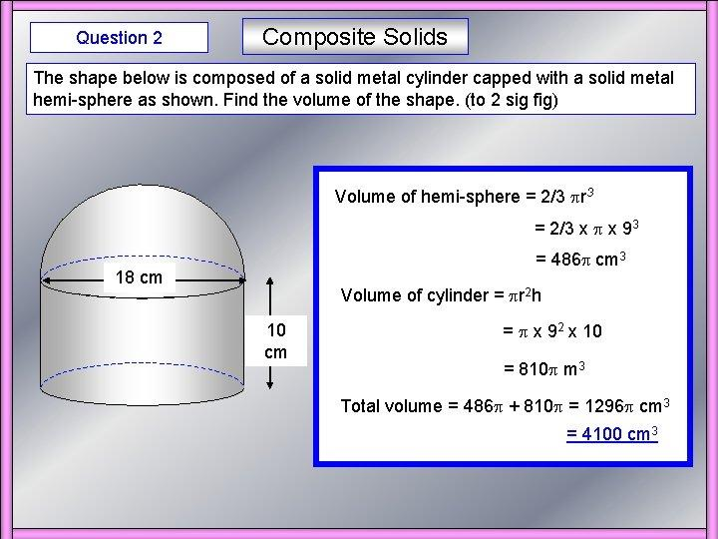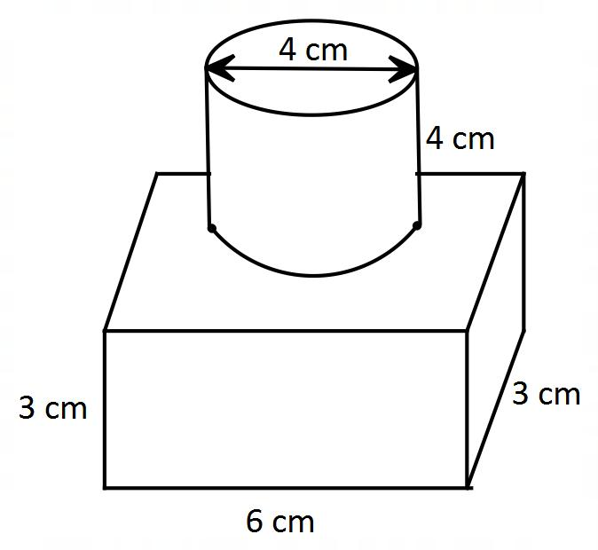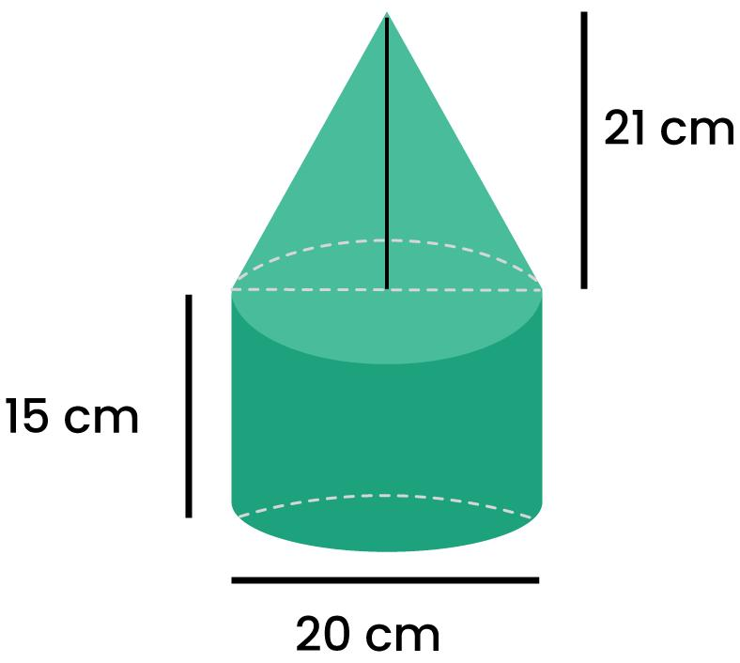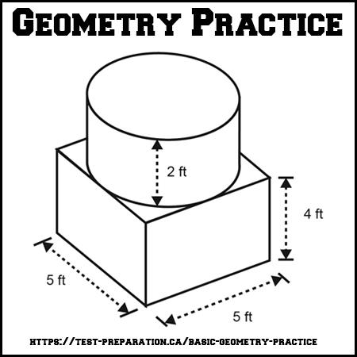
Created by combining a cylinder with other geometric solids.
Examples:
- Cylinder with a hemisphere attached to one end.
- Cylinder with a cone on top.
- Cylinder with a rectangular prism attached.
- Cylinder with a spherical projection.
- Cylinder with a hemispherical base.

Cone-Based Composite Solids
# Source: AI Source: Provided by: [Data Path: Persons Table -> ID Column: 1, Name_En Column: Motasem Essam] -> From: [ChatGPT] on [7/25/2026]
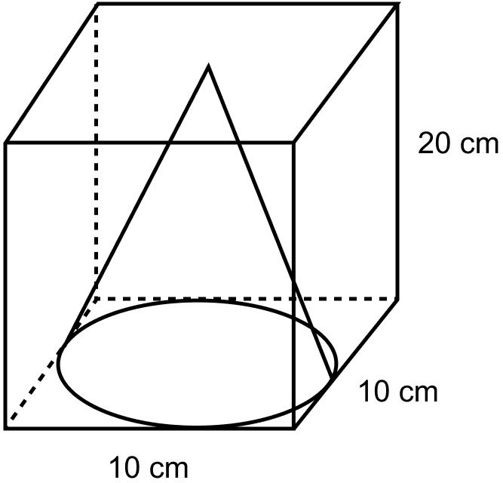
Created by combining a cone with solids that have flat or curved surfaces.
Examples:
- Cone attached to a cylindrical base.
- Cone with a hemisphere attached.
- Cone attached to a rectangular prism.
- Cone with a cylindrical extension.
- Cone combined with a spherical section.

Sphere-Based Composite Solids
# Source: AI Source: Provided by: [Data Path: Persons Table -> ID Column: 1, Name_En Column: Motasem Essam] -> From: [ChatGPT] on [7/25/2026]
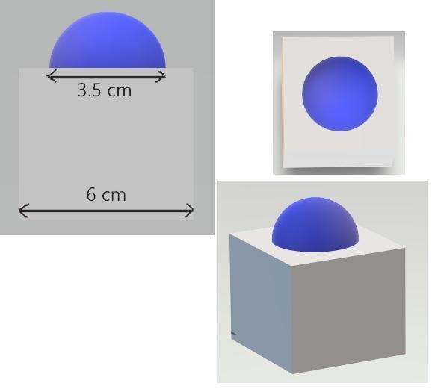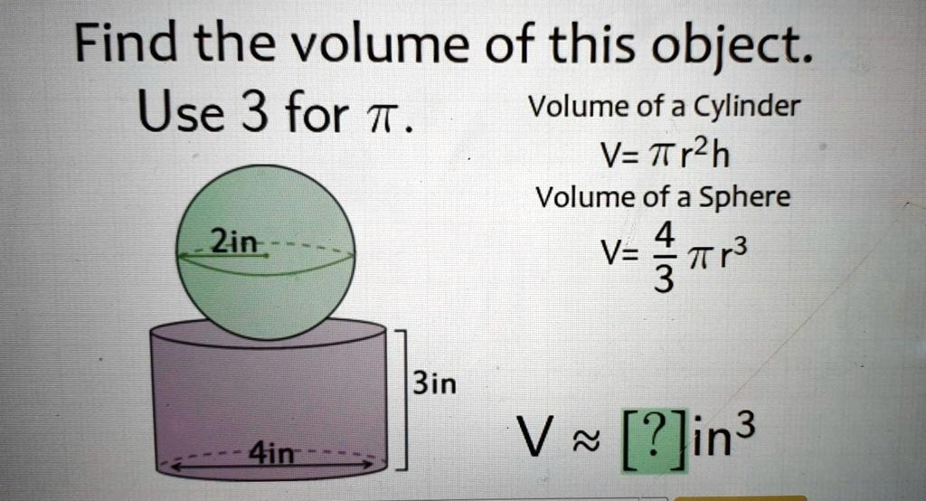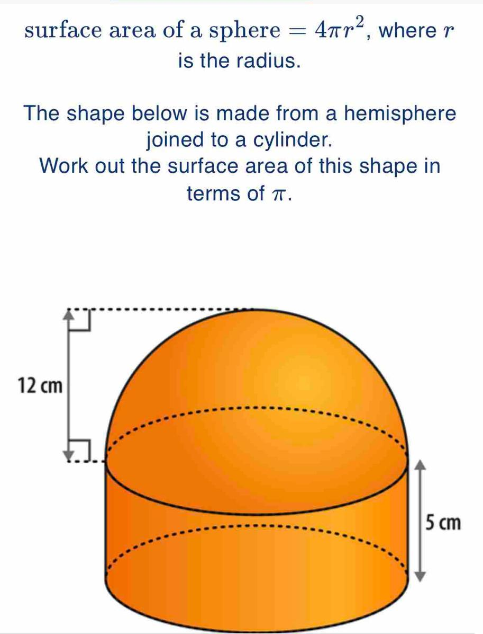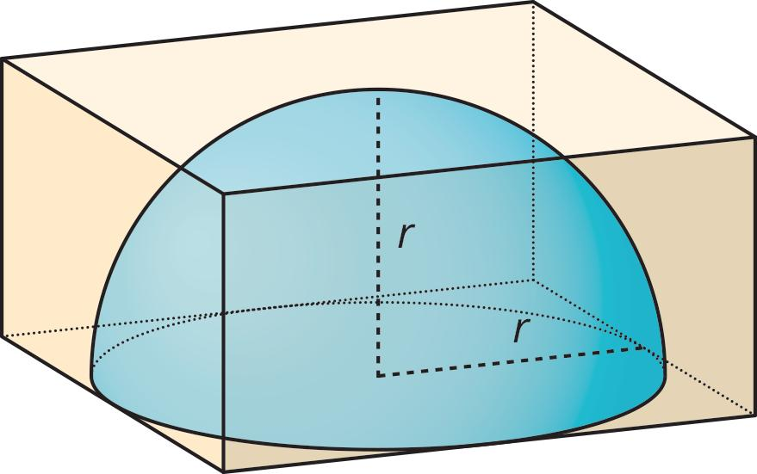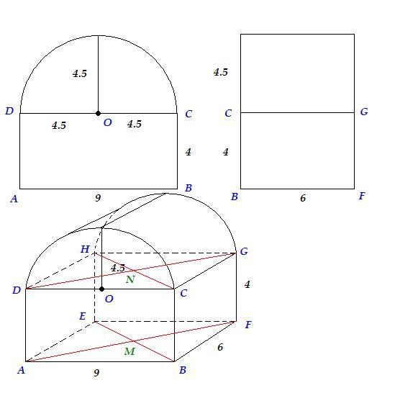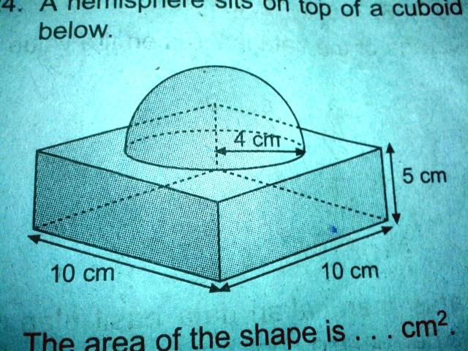
Created by combining a sphere or a portion of a sphere with solids containing flat surfaces.
Examples:
- Hemisphere attached to a rectangular prism.
- Sphere attached to a cylinder.
- Hemisphere on top of a cube.
- Spherical cap attached to a cylindrical solid.
- Hemisphere combined with a triangular prism.

Mixed-Shape Composite Solids
# Source: AI Source: Provided by: [Data Path: Persons Table -> ID Column: 1, Name_En Column: Motasem Essam] -> From: [ChatGPT] on [7/25/2026]
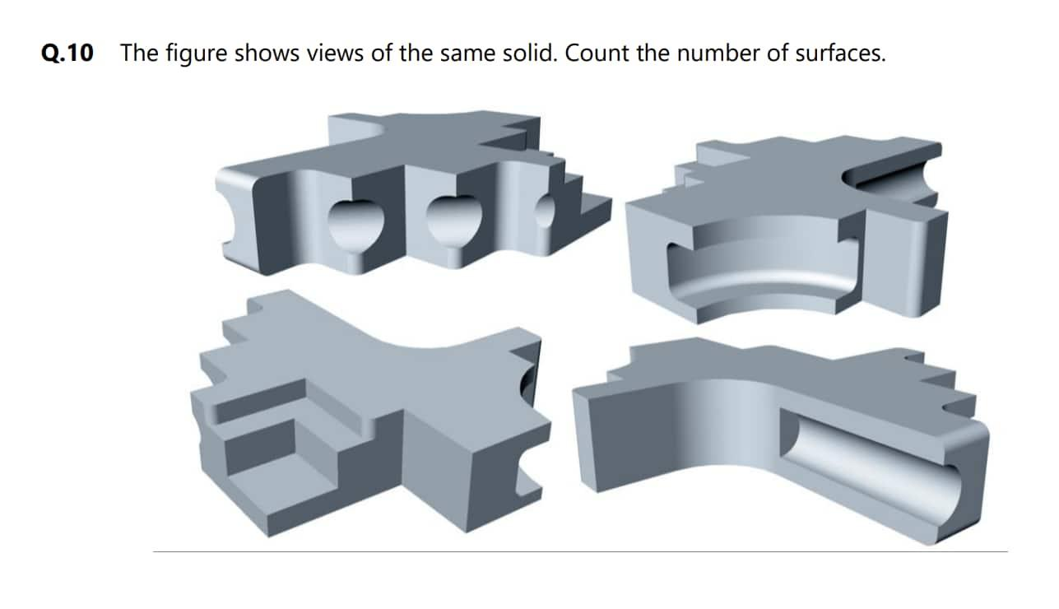
Created by combining three or more different geometric shapes, producing a solid with multiple types of flat and curved surfaces.
Examples:
- Rectangular prism combined with a cylinder and a hemisphere.
- Cube combined with a cylinder and a cone.
- Cylindrical base with a conical top and hemispherical cap.
- Rectangular prism combined with cylindrical and spherical sections.
- Complex solid containing prisms, cylinders, cones, and spherical sections.

Classification by Surface Combination
# Source: AI Source: Provided by: [Data Path: Persons Table -> ID Column: 1, Name_En Column: Motasem Essam] -> From: [ChatGPT] on [7/25/2026]
Composite solids with flat and curved surfaces can also be classified according to the types of surfaces present on their boundaries.
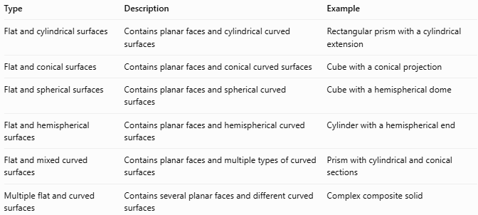
Type | Description | Example
Flat and cylindrical surfaces | Contains planar faces and cylindrical curved surfaces | Rectangular prism with a cylindrical extension
Flat and conical surfaces | Contains planar faces and conical curved surfaces | Cube with a conical projection
Flat and spherical surfaces | Contains planar faces and spherical curved surfaces | Cube with a hemispherical dome
Flat and hemispherical surfaces | Contains planar faces and hemispherical curved surfaces | Cylinder with a hemispherical end
Flat and mixed curved surfaces | Contains planar faces and multiple types of curved surfaces | Prism with cylindrical and conical sections
Multiple flat and curved surfaces | Contains several planar faces and different curved surfaces | Complex composite solid

Mathematical Properties and Formulas

Volume
# Source: AI Source: Provided by: [Data Path: Persons Table -> ID Column: 1, Name_En Column: Motasem Essam] -> From: [ChatGPT] on [7/25/2026]
The volume of a composite solid is calculated by combining the volumes of its component solids.
For components joined without overlapping interiors:
$$\boxed{V_{total}=∑_{i=1}^{n}V_{i}}$$
Where:
- $V_{total}$: Total volume of the composite solid.
- $V_{i}$: Volume of each component solid.
- $n$: Number of component solids.
If components overlap, their intersection volumes must not be counted more than once.

Volume of Common Component Solids
# Source: AI Source: Provided by: [Data Path: Persons Table -> ID Column: 1, Name_En Column: Motasem Essam] -> From: [ChatGPT] on [7/25/2026]
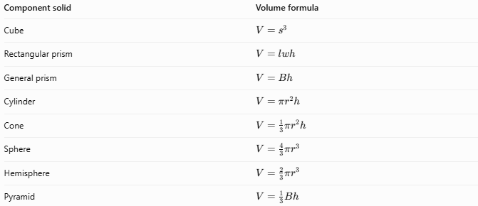
Component solid | Volume formula
Cube | $$V=s^{3}$$
Rectangular prism | $$V=lwh$$
General prism | $$V=Bh$$
Cylinder | $$V=πr^{2}h$$
Cone | $$V=\frac{1}{3}πr^{2}h$$
Sphere | $$V=\frac{4}{3}πr^{3}$$
Hemisphere | $$V=\frac{2}{3}πr^{3}$$
Pyramid | $$V=\frac{1}{3}Bh$$

External Surface Area
# Source: AI Source: Provided by: [Data Path: Persons Table -> ID Column: 1, Name_En Column: Motasem Essam] -> From: [ChatGPT] on [7/25/2026]
The external surface area is the total area of the exposed outer surfaces of the composite solid.
$$\boxed{{SA}_{total}=∑A_{exposed}}$$
The calculation must consider:
- Exposed flat faces.
- Exposed curved surfaces.
- Circular or other boundaries between components.
- Contact surfaces hidden where components are joined.
Important: The areas of surfaces inside the composite solid or covered by another component must not be included.

Common Surface Area Formulas
# Source: AI Source: Provided by: [Data Path: Persons Table -> ID Column: 1, Name_En Column: Motasem Essam] -> From: [ChatGPT] on [7/25/2026]
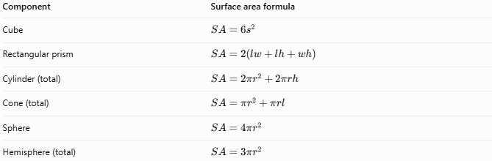
Component | Surface area formula
Cube | $$SA=6s^{2}$$
Rectangular prism | $$SA=2(lw+lh+wh)$$
Cylinder (total) | $$SA=2πr^{2}+2πrh$$
Cone (total) | $$SA=πr^{2}+πrl$$
Sphere | $$SA=4πr^{2}$$
Hemisphere (total) | $$SA=3πr^{2}$$
Where $l$ in the cone formula represents the slant height.

Worked Examples

Example 1: Cylinder with a Hemispherical End
# Source: AI Source: Provided by: [Data Path: Persons Table -> ID Column: 1, Name_En Column: Motasem Essam] -> From: [ChatGPT] on [7/25/2026]
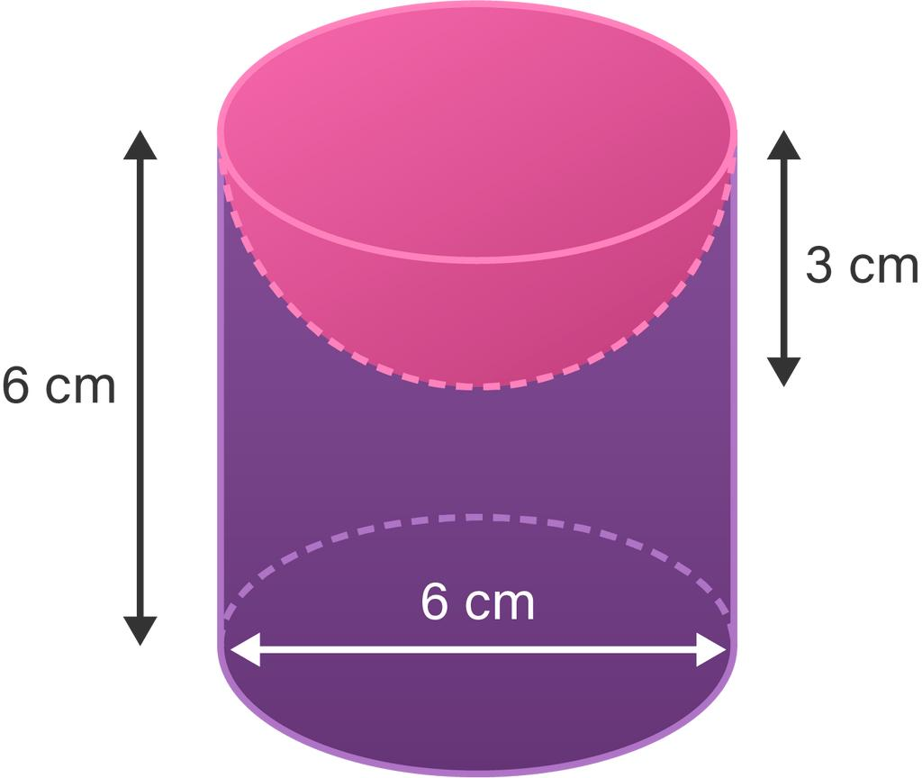
A hemisphere is attached to one end of a cylinder. Both components have the same radius.
Given:
- Cylinder radius: $r=3 cm$
- Cylinder height: $h=8 cm$
- Hemisphere radius: $r=3 cm$
Step 1: Calculate the cylinder volume
$$V_{1}=πr^{2}h$$
$$V_{1}=π(3)^{2}(8)=72π$$
Step 2: Calculate the hemisphere volume
$$V_{2}=\frac{2}{3}πr^{3}$$
$$V_{2}=\frac{2}{3}π(3)^{3}=18π$$
Step 3: Calculate the total volume
$$V_{total}=72π+18π$$
$$\boxed{V_{total}=90π≈282.74{ cm}^{3}}$$
Step 4: Calculate the external surface area
The exposed surfaces consist of:
- Cylinder curved surface: $2πrh$
- One exposed circular base: $πr^{2}$
- Hemisphere curved surface: $2πr^{2}$
$$SA=2πrh+πr^{2}+2πr^{2}$$
$$SA=2π(3)(8)+3π(3)^{2}$$
$$\boxed{SA=75π≈235.62{ cm}^{2}}$$

Example 2: Rectangular Prism with a Semicylindrical Top
# Source: AI Source: Provided by: [Data Path: Persons Table -> ID Column: 1, Name_En Column: Motasem Essam] -> From: [ChatGPT] on [7/25/2026]
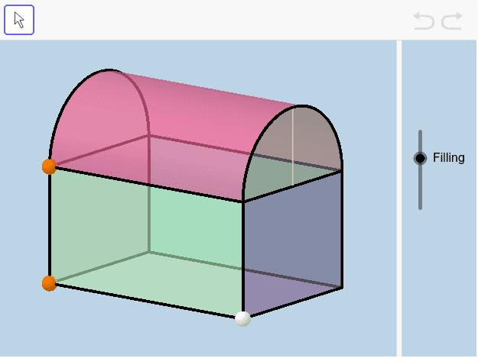
A semicylinder is placed on top of a rectangular prism. The semicylinder has the same width as the prism.
Given:
- Prism length: $l=10 cm$
- Prism width: $w=6 cm$
- Prism height: $h=4 cm$
- Semicylinder radius: $r=3 cm$
- Semicylinder length: $L=10 cm$
Step 1: Calculate the rectangular prism volume
$$V_{1}=lwh$$
$$V_{1}=10(6)(4)=240$$
Step 2: Calculate the semicylinder volume
$$V_{2}=\frac{1}{2}πr^{2}L$$
$$V_{2}=\frac{1}{2}π(3)^{2}(10)=45π$$
Step 3: Calculate the total volume
$$V_{total}=240+45π$$
$$\boxed{V_{total}≈381.37{ cm}^{3}}$$
Step 4: Calculate the external surface area
The exposed surfaces consist of:
- Bottom face: $60$
- Two rectangular side faces: $80$
- Two rectangular end faces: $48$
- Semicylindrical curved surface: $30π$
- Two semicircular end faces: $9π$
$$SA=60+80+48+30π+9π$$
$$\boxed{SA=188+39π≈310.52{ cm}^{2}}$$

Important Characteristics
# Source: AI Source: Provided by: [Data Path: Persons Table -> ID Column: 1, Name_En Column: Motasem Essam] -> From: [ChatGPT] on [7/25/2026]
- Combine geometric components with flat and curved surfaces.
- May contain two or more different geometric solids.
- Include planar faces and curved surfaces.
- May contain circular, semicircular, or other curved boundaries.
- Components may have different or matching dimensions.
- The contact surfaces between components are generally internal and not exposed.
- Volume is calculated by combining the volumes of the components, accounting for overlaps.
- External surface area includes only exposed surfaces.
- The resulting solid may have a complex three-dimensional boundary.

Comparison with Other Types of Composite Solids
# Source: AI Source: Provided by: [Data Path: Persons Table -> ID Column: 1, Name_En Column: Motasem Essam] -> From: [ChatGPT] on [7/25/2026]
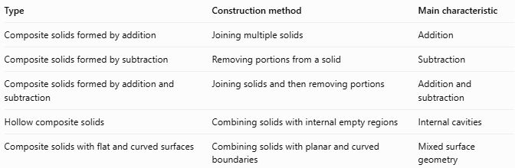
Type | Construction method | Main characteristic
Composite solids formed by addition | Joining multiple solids | Addition
Composite solids formed by subtraction | Removing portions from a solid | Subtraction
Composite solids formed by addition and subtraction | Joining solids and then removing portions | Addition and subtraction
Hollow composite solids | Combining solids with internal empty regions | Internal cavities
Composite solids with flat and curved surfaces | Combining solids with planar and curved boundaries | Mixed surface geometry

Applications
# Source: AI Source: Provided by: [Data Path: Persons Table -> ID Column: 1, Name_En Column: Motasem Essam] -> From: [ChatGPT] on [7/25/2026]
- Mechanical engineering: Designing components with cylindrical extensions, rounded ends, and flat mounting surfaces.
- Architecture: Designing buildings with domes, curved roofs, columns, and rectangular structures.
- Construction: Creating structures with curved and planar sections.
- Product design: Designing containers, housings, handles, and decorative objects.
- Manufacturing: Producing objects that combine flat faces with curved surfaces.
- Computer-aided design (CAD): Modeling complex 3D objects using combinations of primitive geometric solids.

Key Points
# Source: AI Source: Provided by: [Data Path: Persons Table -> ID Column: 1, Name_En Column: Motasem Essam] -> From: [ChatGPT] on [7/25/2026]
- Composite solids with flat and curved surfaces combine different geometric components.
- Their boundaries contain both planar and curved surfaces.
- Common components include prisms, cylinders, cones, spheres, and hemispheres.
- Their volume is calculated using the volumes of their individual components.
- Their external surface area includes only exposed surfaces.
- Internal contact surfaces must be excluded from external surface area calculations.
- These solids are widely used in geometry, engineering, architecture, manufacturing, and CAD.

Conclusion
# Source: AI Source: Provided by: [Data Path: Persons Table -> ID Column: 1, Name_En Column: Motasem Essam] -> From: [ChatGPT] on [7/25/2026]
Composite solids with flat and curved surfaces are three-dimensional geometric objects formed by combining geometric solids with planar and curved boundaries. They may include prisms, cylinders, cones, spheres, and hemispheres. Understanding their geometric components, volume, and external surface area provides a foundation for analyzing complex three-dimensional objects and their practical applications.

